A Project Report
On
"Wireless Status Display"

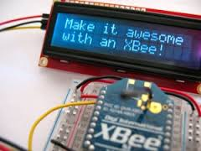

Prepared by
Ravikumar Patel (11CE086)
Under the guidance of
Prof. Nishidh Chavda

Submitted to
Charotar University of Science & Technology
For Partial Fulfillment of the Requirements for the
Degree of Bachelor of Technology
In Computer Engineering
CE408 -Software Project Major
Of 8th Semester of B.Tech
Submitted at

U & P U. PATEL DEPARTMENT OF COMPUTER ENGINEERING
Chandubhai S. Patel Institute of Technology (CSPIT)
Faculty of Technology & Engineering (FTE), CHARUSAT
At: Changa, Dist: Anand, Pin: 388421.

